Understanding World Order: How the Pieces Fit Together

Imagine the world as a giant schoolyard. Not everyone is friends, and different groups form for various reasons: safety, power, or friendship. The 'world order' is like the set of rules and agreements that keeps things running smoothly, or at least as smoothly as possible, even if there's occasional chaos. It's about how countries, like the kids in the schoolyard, relate to each other.

# The Schoolyard of Nations

Think of every country as a player in a big game, like different children in a schoolyard. Some countries are stronger or bigger, and their strength allows them to set certain rules. These rules dictate who can hang out where (borders), how they share snacks (resources like oil, money), and how they get along with the adults (international laws or organizations that oversee things).

Image a schoolyard filled with children of different sizes. The bigger ones form groups, make friends, and sometimes set playground rules, while smaller ones try to align with them for protection or privilege.

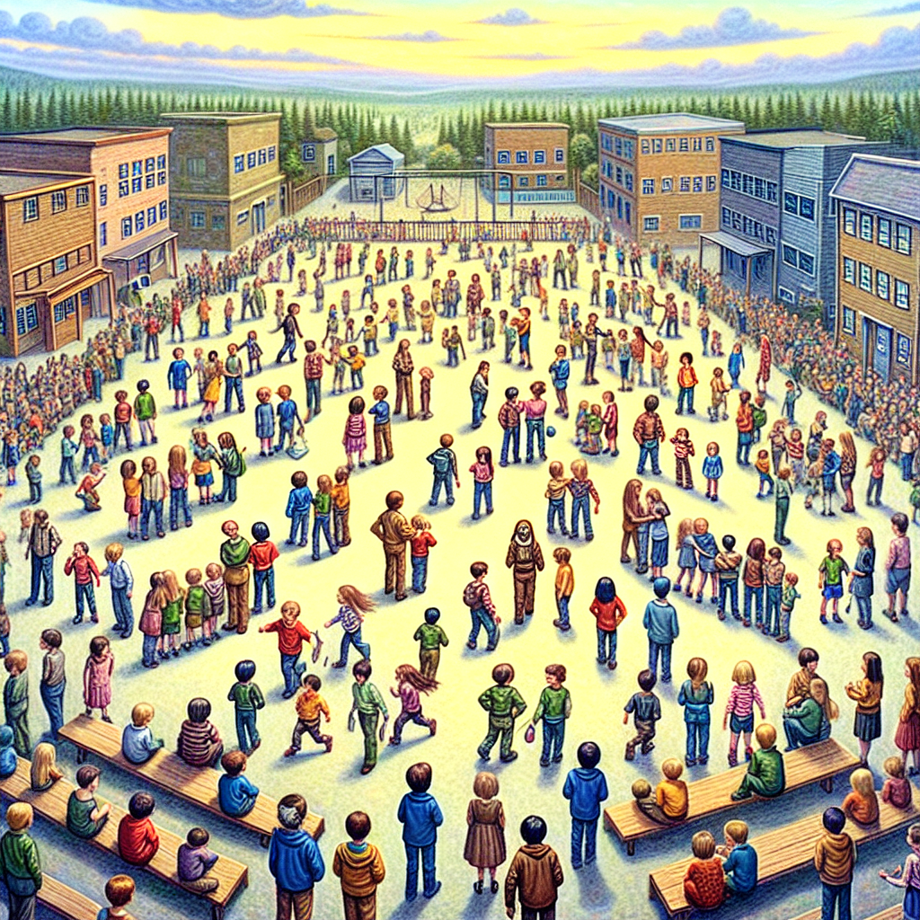

Now that we've established that countries have relationships based on power and shared interests, let's see what happens when countries work together... or don't.

# Teamwork & Rivalries

In the world order, countries team up, forming alliances or partnerships. Imagine a few kids in the schoolyard deciding to build a fort together. They help each other out because they have common goals--maybe they want to feel safer from bullies (security), be stronger than other groups (power), or simply because they like each other (diplomatic relations). But just like in the schoolyard, rivalries exist too. One group might want what another group has, or they disagree about how things should work.

Image of groups of kids building forts on different corners of the schoolyard. Some groups exchange food or toys, but others stare at each other suspiciously, ready to compete or challenge one another.

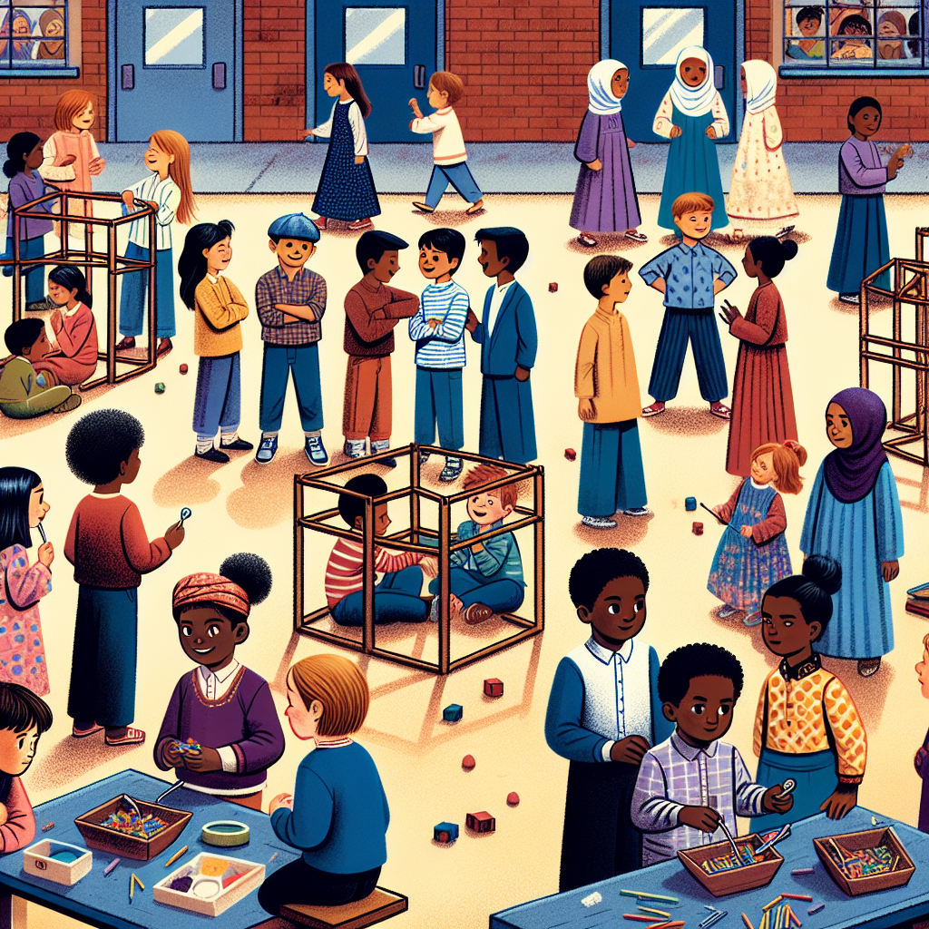

As alliances and rivalries grow, there's a need for ways to keep order, sort out arguments, and make sure the rules are followed. That's where the idea of systems and institutions comes in.

# Setting the Rules: Who Decides?

Just like in a school, where teachers and administrators create rules to keep everyone in line, the world has its own 'rule-makers.' These can be powerful countries or organizations like the United Nations. Their job is to ensure everyone follows the same basic guidelines, like not invading each other or protecting human rights. But just like some kids in school might bend the rules to their advantage, some countries follow these rules only when it's convenient.

Imagine a large teacher or supervisor standing on the schoolyard bench, blowing a whistle, while different kids either listen, argue, or find ways around the rules unnoticed.

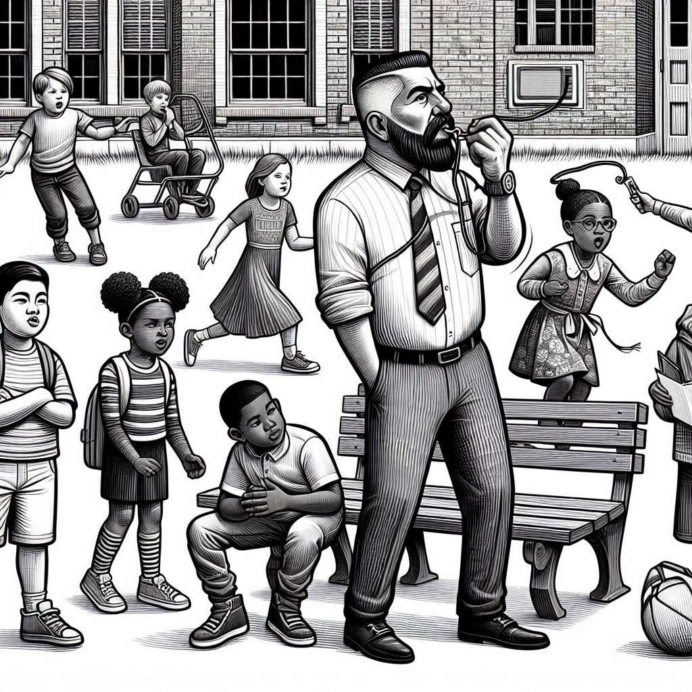

But enforcing rules isn't always easy, especially when some kids are way bigger or stronger. Let's explore how power shifts and who holds the most influence over time.

# Who's in Charge Now?

In our schoolyard analogy, there's always that one big kid (or a small group of them) that everyone else listens to--whether they like it or not. Historically, some countries have been very powerful (like the British Empire or the United States), and they shaped the world order based on what worked best for them. However, over time, new players (countries) rise, challenging the big kids and shifting the balance. Every now and then, the schoolyard dynamic changes, with someone new leading the group or a tug-of-war between old and new powers.

Picture a group of the biggest kids gathered in the middle, making decisions. But off to one side, a few newer, stronger kids are slowly making their way into the circle, challenging the status quo.

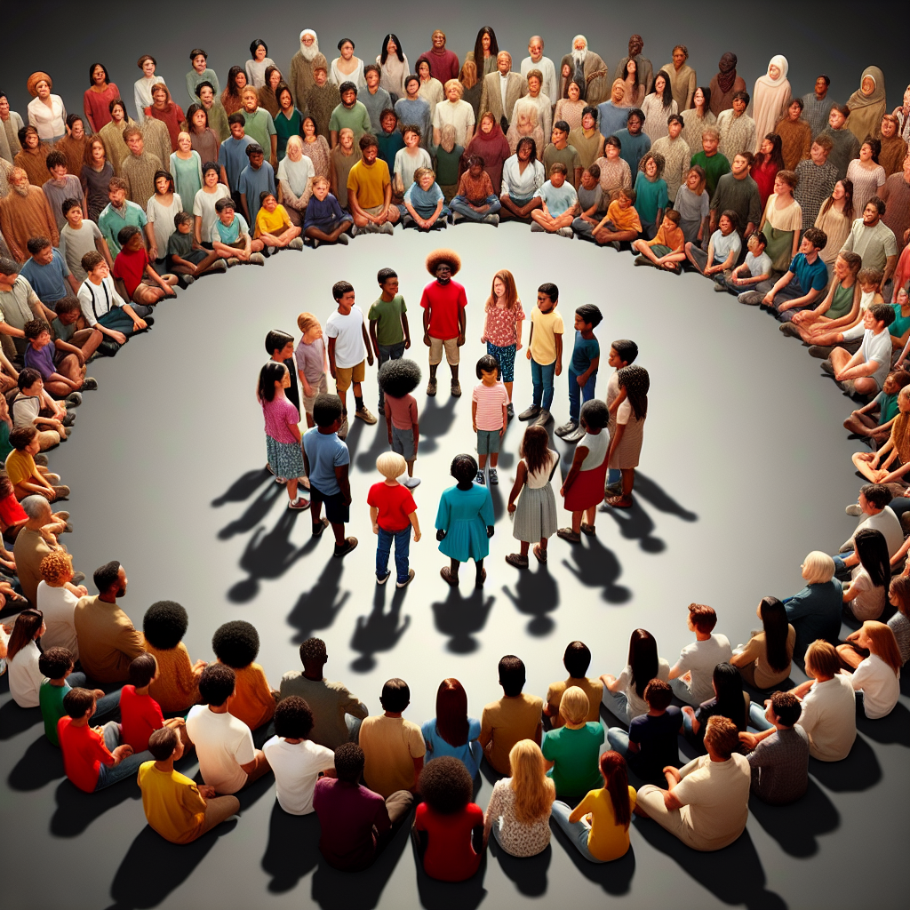

As power shifts and countries grow stronger or weaker, the whole idea of world order changes. Let's see how these changes unfold over time.

# Ups and Downs: Things Constantly Change

The world order isn't set in stone. A country that's powerful today might weaken tomorrow, and new players might rise. Just like in a schoolyard where friends fall out or new kids arrive and shake things up, the global scene is always evolving. Wars, economic crises, or influential leaders can change how countries interact. Sometimes, these changes are massive, like a whole new group of kids coming in and setting entirely new rules.

Imagine the entire schoolyard suddenly reshuffling, with kids switching teams, new alliances forming, and the old 'rulers' finding themselves having to adjust to a totally different set of new leaders and rules.

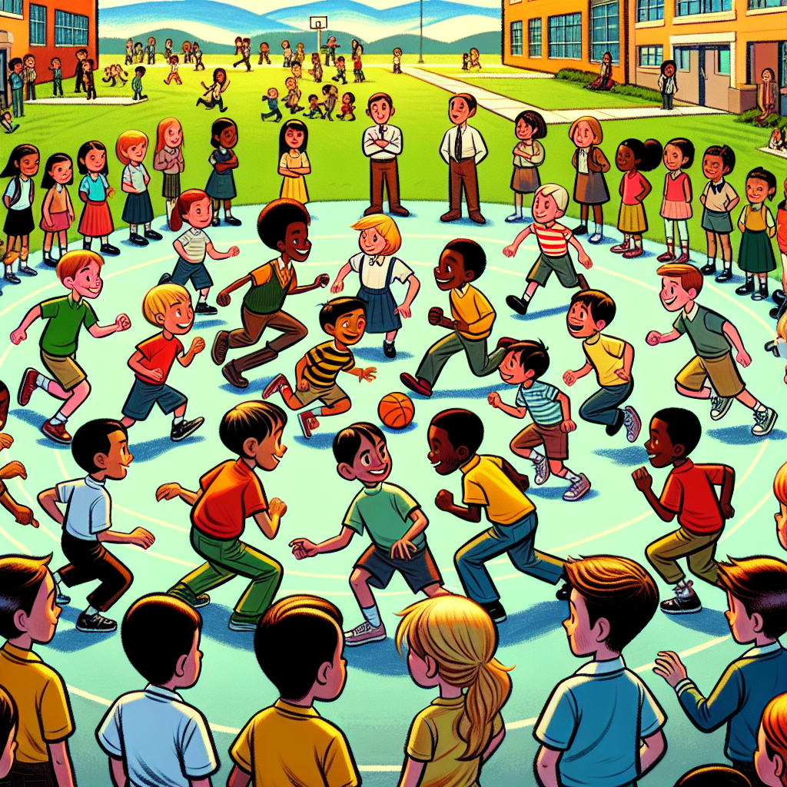

And that's the essence of world order--it's a big, messy, ever-changing game where countries constantly negotiate, compete, and cooperate.

# Conclusion

So, world order is like the unspoken, sometimes fragile rules of a giant schoolyard. Powerful countries or alliances tend to shape it, but it's never static. Countries team up, argue, and adjust as new challenges arise, and major shifts happen when stronger new players arrive or old powers weaken. Essentially, it's how the world 'gets along' day by day, and it's always evolving.